Huge Wave and Droplet Entrainment in Churn Flow

Bofeng Bai¹ and Ke Wang^{1,2}

1. Xi'an Jiaotong University, State Key Laboratory of Multiphase Flow in Power Engineering
No.28, Xianning West Road, Xi’an, 710049, China
2. China University of Petroleum, Beijing Key Laboratory of Process Fluid Filtration and Separation
No.18, Fuxue Road, Changing, Beijing, 102249, China
E-mail: bfbai@mail.xjtu.edu.cn

Churn flow is one of the least understood gas-liquid flow regimes due to its complexity and there have been enduring efforts to define it. Generally, churn flow is considered as an intermediate flow regime between slug flow and annular flow and occurs after the break-down of slug flow as its velocity increases. As it frequently occurs in power plants, chemical engineering, petroleum and other industrial applications, churn flow has a significant influence on the safety and management control.
Churn flow appears a highly-disturbed flow of gas and liquid and is generally characterized by the presence of a very thick and unstable liquid film with the liquid frequently oscillating up and down. It normally occurs in vertical or nearly vertical pipes and features interfacial waves, termed as huge waves, over a liquid film which are larger in amplitude, wavelength and velocity than disturbance waves. Profound knowledge on the huge wave properties, mechanisms of entrainment and entrained droplets in churn flow is crucial to provide better understanding of churn flow. Due to the complexity of churn flow, these issues are not well documented in the existing literature.
The existence of huge waves (or called flooding-type wave or large wave) formed on the thin falling liquid film is one of the most important features of churn flow. The liquid is transported upwards in the huge wave which intakes the liquid from a foregoing falling film and sheds the liquid to a falling film behind them. The wave reversal is found to be the most significant feature during the whole process and believed to be the reason for the liquid oscillation under the churn flow condition: the huge wave periodically forms and grows in both the radial and axial direction, as shown in Figure 1.
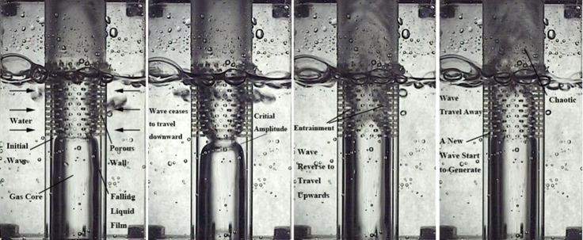
t=0ms t=30ms t=50ms t=80ms
=19 mm, =6.17m/s, =7.49×10⁻³m/s, =0.49
Figure 1: Evolution of huge waves in churn flow

The oscillation of the falling liquid film shows different features during the transition from churn flow to annular flow, i.e. it experiences four states: from the unstable to the stable and then to the unstable again, and finally disappearing when entering annular flow. The effect of the interfacial shear stress varies during the transition from churn flow to annular flow, and combines with other factors (gravity, inertia and viscosity, and surface tension included), resulting in the oscillation of the falling liquid film under two conditions: at the lower gas superficial velocity or near the churn-to-annular transition.
During the upward moving process, part of the liquid is entrained into the gas core, and eventually breaks up into droplets of various sizes. Three main mechanisms for droplet generation are found in churn flow, as illustrated in Figure 2. In the slug-churn flow transition, with an increase in gas flow rate, the Taylor bubble becomes seriously distorted. The liquid slug shrinks and finally collapses into liquid chunks. This breakdown of liquid slug results in a sudden acceleration and impels the chunks to break up into small droplets (see Figure 2a). Subsequently, the falling liquid accumulates, forming the so-called huge wave, and is again broken up by the gas. Thus, the bag breakup (undercut) plays a dominant role at low gas superficial velocity (see Figure 2b), whereas the ligament breakup (sheared-off) comes to gain greater importance with the increase of gas flow rate (see Figure 2c). In the case of ligament breakup, the wave crest is ‘‘stretched” into the gas core (see the protrusion in Figure 2c) and then sheared off by the coming gas flow. The filament subsequently breaks up into small droplets. Comparably, small droplets tend to stay in the core for much longer due to the turbulent eddy interactions within the gas core. In the case of bag breakup mechanism, an open-ended bubble is formed with a thick filament rim and the part of the wave is undercut to form a liquid chunk. Subsequently, the chunk breaks up into smaller droplets or deposits instantly on the liquid film to cause a secondary entrainment (impingement) to generate smaller droplets.
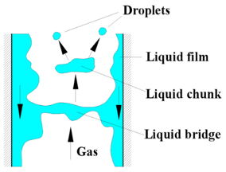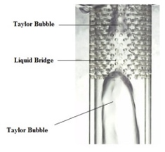
Principle Axial Cross-section
- Bridge break down
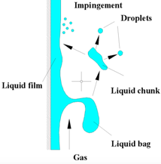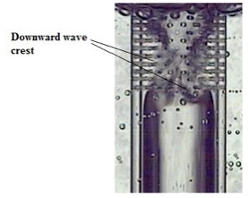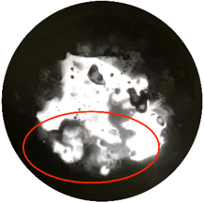
Principle Axial Cross-section
(b) Bag breakup and droplet impingement
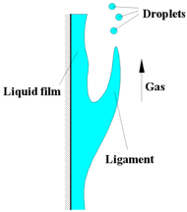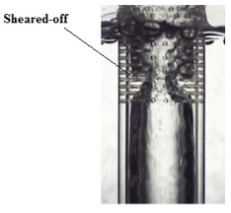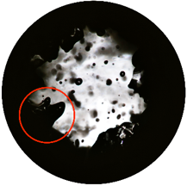
Principle Axial Cross-section
(c) Ligament breakup
Figure 2: The mechanisms of droplet generation.

We analyzed the effects of gas and liquid phases on the wave behavior and found that flooding of the film was a characteristic of the churn flow through out of the regime. Falling film was observed to go through a process from unstable to stable and unstable again from churn flow to annular flow, depending on the comparison among gravity, surface tension and countercurrent or cocurrent shear stress. Therefore, Orr-sommerfeld equations were solved to investigate the effect of gas and liquid flow on the film stability and two thresholds of shear stress were obtained and discussed in detailed. According to the analysis of the initial condition of huge wave movement, it can be inferred that the huge wave disappears as the sign for the transition from the churn flow to the annular flow.
Bag break-up mechanism and ligament break-up mechanism were found coexistent in churn flow. At lower gas velocity, larger drops are generated from the huge waves through the bag break-up mechanism. As the gas flow rate increased and this under-cutting mechanism subsided, leading to decrease entrainment. With further increasing of the gas flow rate, the ligament breakup gained greater importance and generated relative smaller drops. In the cross-section of the pipe, the amount of liquid entrained is high in churn flow and decreases with increasing gas velocity, reaches the minimum around the churn-annular flow transition.
The underlying physical behavior for the drop entrainment is believed to be the Kelvin-Helmholtz instability. We established an analytical model based on this theory to study the drop entrainment under churn flow condition. The proposed model was verified qualitatively and quantitatively and we analyzed in detail the impact of the gas and liquid flow rate, pipe diameter and pressure on the drop entrainment rate. Thus, we proposed a more accurate formula for the entrainment rate in churn flow based on the comparative analysis with entrainment rate in annular flow. The new formula was then compared with existing prediction equation, and the results obtained have been discussed and believed to be more well in agreement with the real entrainment process.
Since entrained drops in churn flow have “memory effect” on the flow in annular flow, a developed film flow model was established to predict the critical heat flux in churn flow regime. By analyzing the impact of the entrainment fraction at the onset of annular flow on the prediction of the critical heat flux and referring to our experimental results, we pointed out that the commonly used approaches about the onset entrainment fraction of annular flow was lack of theoretical basis. Thus, we considered the drop “memory effect” and proposed that it should be carried out the integration process in film flow model from the onset of churn flow rather than annular flow and provided a more reasonable assumption of the entrainment fraction at the onset of churn flow. The results indicated that the developed model ensure an accuracy of prediction and reflect a more realistic influence of flow pattern on the critical heat flux.

References

Azzopardi, B.J., Drops in annular two-phase flow, Int. Journal of multiphase flow, Vol. 23 pp. 1-53 (1997)

Azzopardi, B.J., Wren, E., What is entrainment in vertical two-phase churn flow? Int. Journal of Multiphase Flow, Vol. 30 pp 89-103 (2004)

Barbosa, J.R., Govan, A.H. and Hewitt, G.F., Visualization and modeling studies of churn flow in a vertical pipe, Int. Journal of multiphase flow, Vol. 27 pp. 2105-2127 (2001)

Barbosa, J.R., Hewitt, G.F., König, G., Richardson, S.M., Liquid entrainment, droplet concentration and pressure gradient at the onset of annular flow in a vertical pipe, Int. Journal of multiphase flow, Vol. 28 pp. 943-961 (2002)

Hewitt, G.F. Churn and Wispy Annular Flow Regimes in Vertical Gas–Liquid Flows. Energy & Fuels, Vol. 26 pp. 4067-4077 (2012)

Wang, K., Ye, J., Bai, B. F. Entrained Droplets in Two-phase Churn Flow. Chemical Engineering Science, 2017, 164: 270-278.

Wang, K., Ye, J., Bai, B.F. Profile of huge wave in gas-liquid churn flow. Chem. Eng. Sci., Vol. 163 pp. 137-144 (2017)

Wang, K., Bai, B.F., Ma, W.M. An improved liquid film model to predict the CHF based on the influence of churn flow. Appl. Therm. Eng., Vol. 64 pp. 422-429 (2014)

Wang, K., Ma, W.M., Bai, B.F. A model for droplet entrainment in churn flow. Chem. Eng. Sci., Vol. 104 pp. 1045-1055 (2013)

Wang, K., Ma, W.M., Bai, B.F. Huge wave and drop entrainment mechanism in gas-liquid churn ﬂow. Chem. Eng. Sci., Vol. 104 pp. 638-646 (2013)

Wang, K., Ma, W.M., Bai, B.F., Cui, J.H. A physical model for huge wave movement in gas-liquid churn flow. Chem. Eng. Sci., Vol. 79 pp. 19-28 (2012)

